**Introduction**

**The Holiday Season is Upon Us**

Season Tours & Travels aims at building a community of happy travellers by providing professionally designed vacations with a personal touch. Intending to create a world of affordable tourism and exploring and innovating new paths in the travel business, we embarked on a journey to accomplish our goal of being India's top tours and travel company, a goal we are working hard to attain every day. We provide tailor-made vacations, escorted group tours, luxury vacations, and value-for-money packages across India and the globe. When you're away from home, we'll make you feel at ease! While on tour, enjoy the comfort of delectable Indian cuisine as well as the flavours of regional cuisines.

It's simple to find us! We are always a click or a call away, thanks to our sales offices, selected sales partners, and a 24/7 online presence. A staff of devoted, passionate, and friendly tour managers will be there to assist you every step of the way and guarantee that you have a pleasant, stress-free, and unforgettable journey.

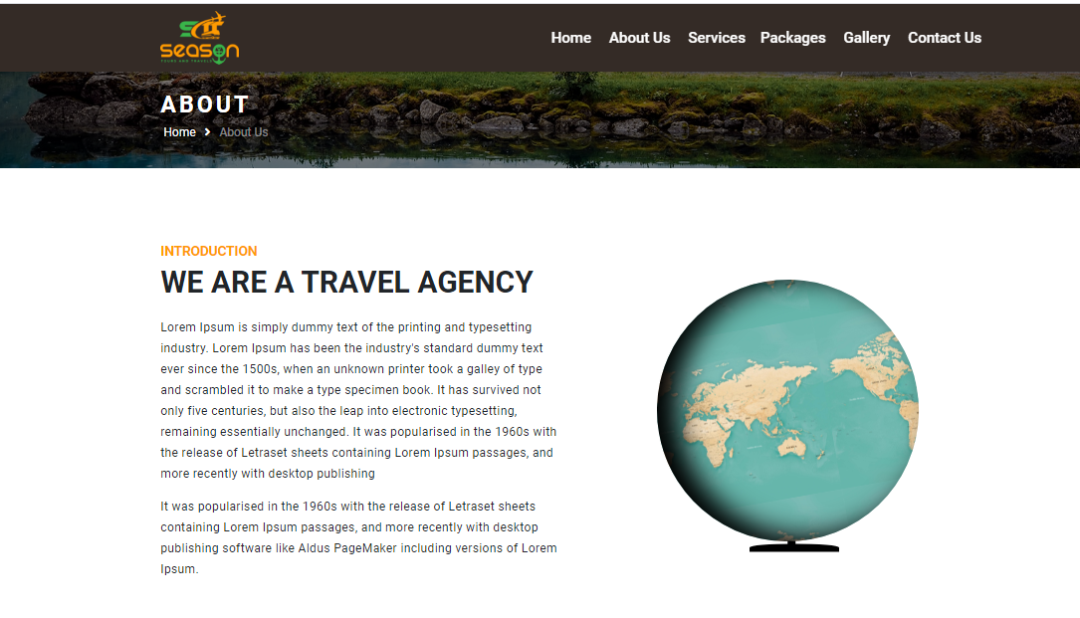

**Mission**

Our mission is to assist individuals, families, and businesses in travelling wisely and achieving more. We strive to offer high-quality travelling service at a reasonable price through exceptional dedication and excellent leadership. We also aim to provide an ecologically and socially responsible approach to tourism.

**Vision**

We aim to be one of the most dependable and forward-thinking tours and travel management companies. We prefer to concentrate on the needs of our clients to develop successful methods for fulfilling their needs in an efficient way connecting people together to provide chances for shared experience, discussion, and development as a travel business.

